NATURE'S ARSONISTS

*Fire-Hunting Raptors of Northern Australia*

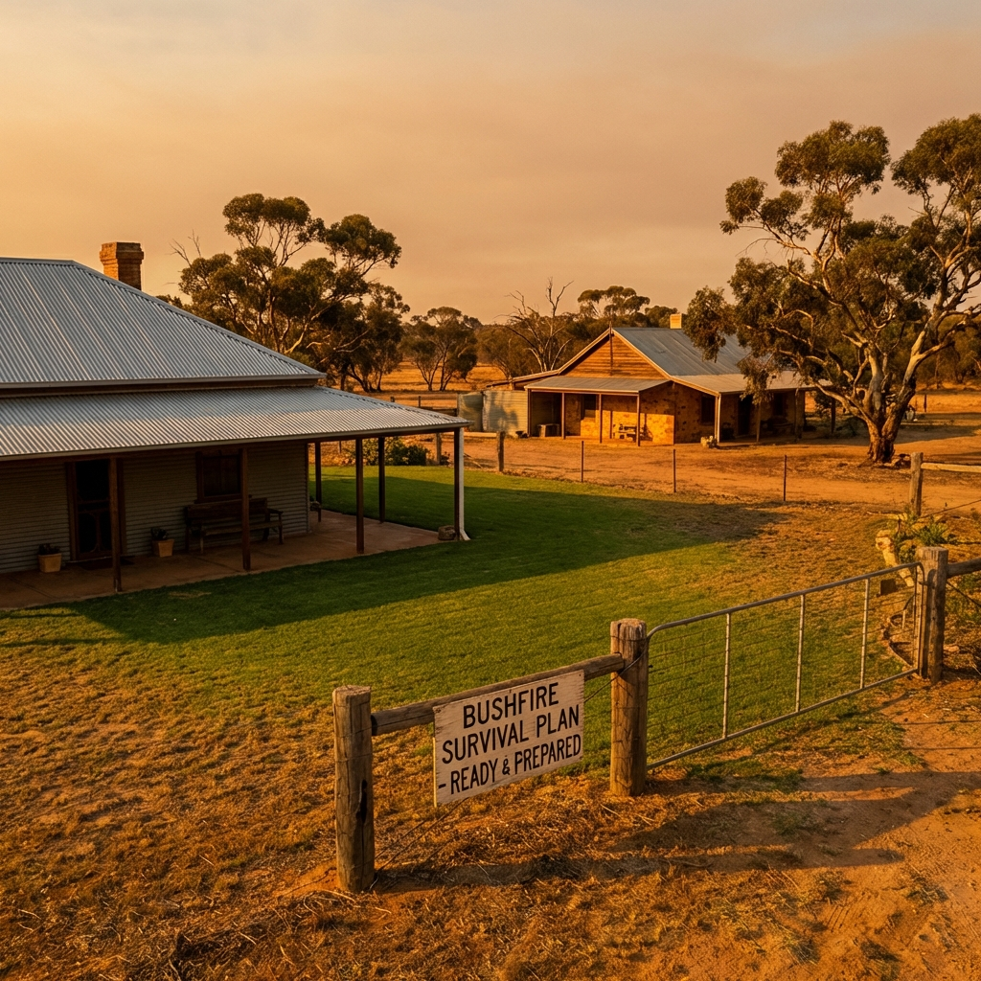

# 01. EXECUTIVE SUMMARY

For decades, people in Northern Australia have told stories about 'Firehawks'—birds that intentionally spread fire. Scientists are now combining Indigenous knowledge with eyewitness accounts to study this amazing behaviour. While some experts are still looking for video proof, local rangers and firefighters have seen these avian arsonists in action many times.

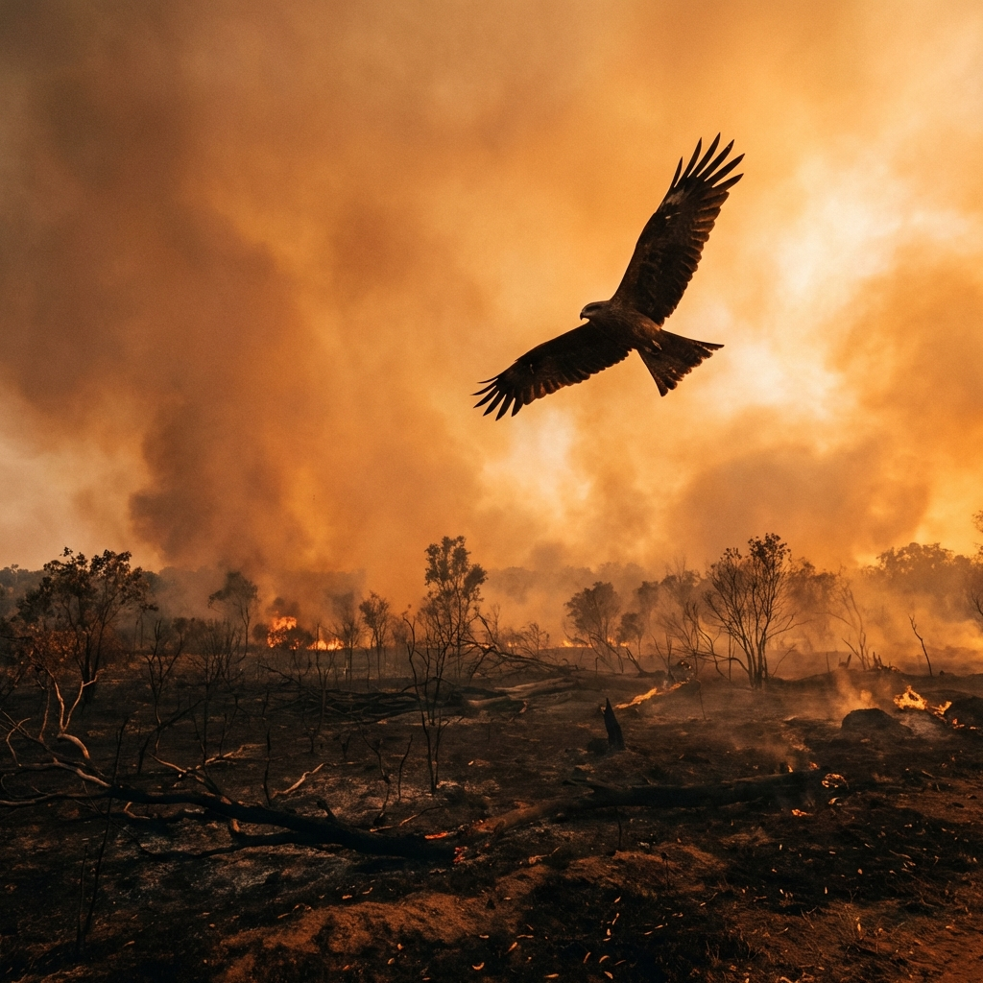

# 02. THE THREE SPECIES

There are three main species of raptors (birds of prey) that have been seen spreading flames in Australia's northern savannas.

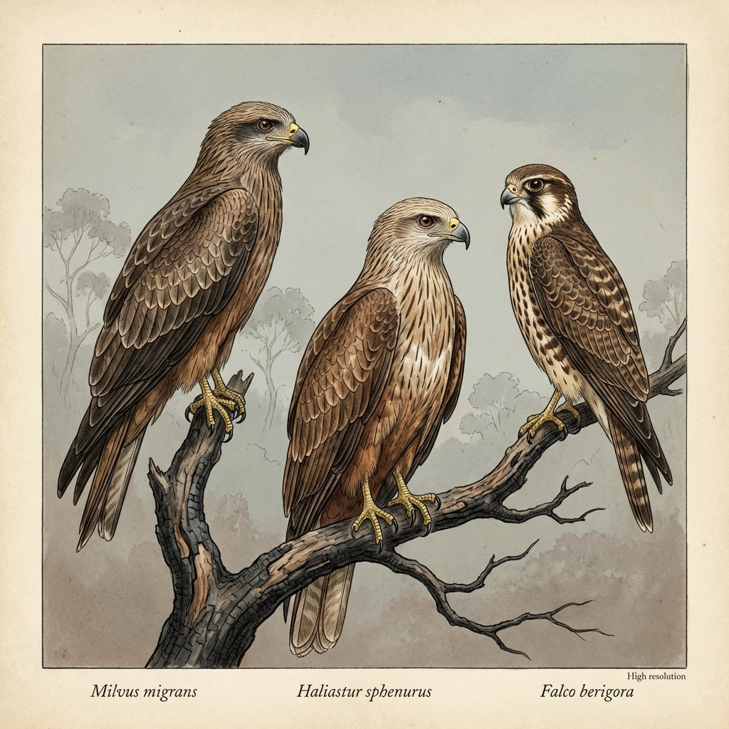

## BLACK KITE (Milvus migrans)

The most abundant and social of the three. They often gather in hundreds around major fires, waiting for prey to emerge from the grass.

## WHISTLING KITE (Haliastur sphenurus)

Named for its loud whistle. These birds have been seen flying ahead of fire fronts with smoking sticks in their talons to start new fires in unburnt areas.

## BROWN FALCON (Falco berigora)

Highly active and focused. Multiple reports describe these falcons specifically moving fire to flush out hidden prey like lizards and insects.

# 03. HOW THEY DO IT

Spreading fire is a deliberate five-step process for a Firehawk. This behaviour allows them to expand the hunting zone by bringing fire to areas where prey might still be hiding.

1. **1. Ignition Gathering:** Birds fly directly into active fires, signalled by the rising smoke.
2. **2. Stick Acquisition:** They find a smouldering stick and grab it with their beak or talons.
3. **3. Transport:** They fly up to 1 kilometre away, often crossing roads or rivers.
4. **4. Deposition:** The burning stick is dropped into dry, unburnt grass.
5. **5. Feeding:** As the new fire flushes out insects and lizards, the bird swoops in for an easy meal!

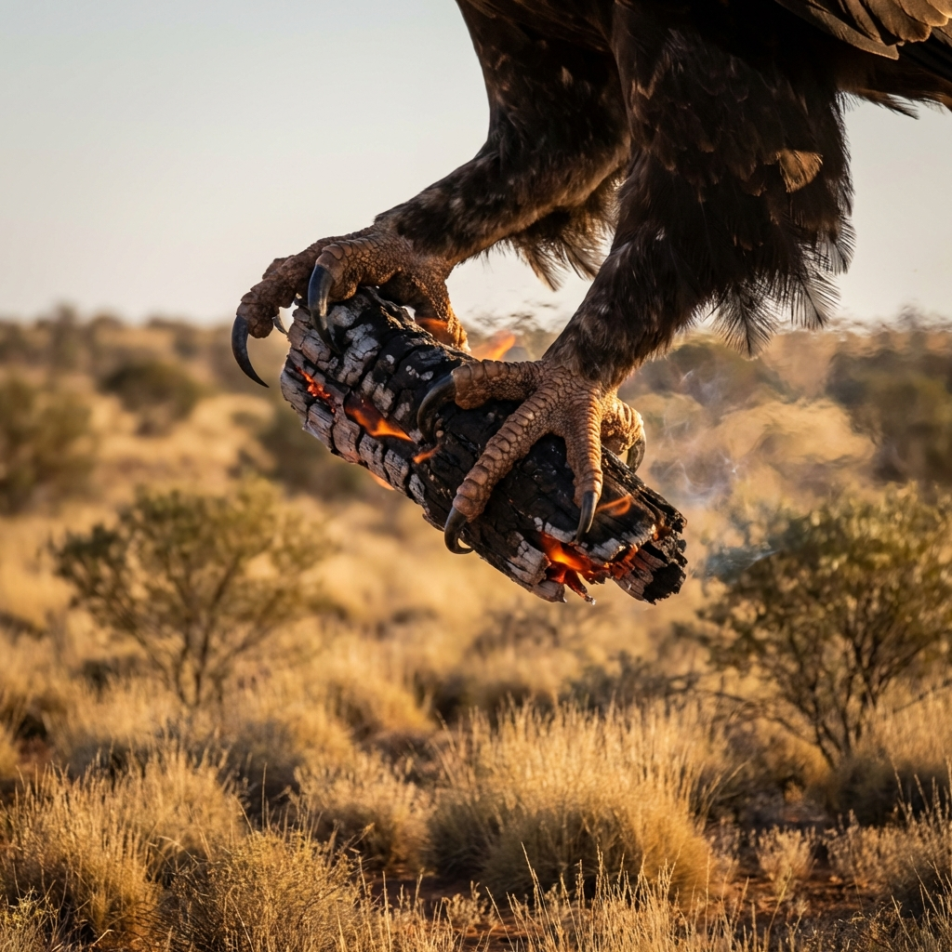

# 04. DO WE HAVE PROOF?

Evidence for this behaviour comes from three main sources: Indigenous knowledge, expert observers, and the boots-on-the-ground experience of firefighters.

## Indigenous Knowledge

Aboriginal groups across Northern Australia have documented these birds for centuries. Over 20 records exist from 12 different groups, some recorded as far back as 1963.

## Expert Observers

Scientists and linguists like Kim Akerman and Denise Angelo have witnessed single birds spreading fire on several occasions during field work in remote areas.

## Firefighters & Rangers

Detailed accounts from practitioners confirm these sightings:

* **Nathan Ferguson (Barkly Tablelands):** Witnessed kites carrying sticks over 50 metres.
* **Dick Eussen (Northern Territory):** Observed new fires ignite across firebreaks in the 1980s.
* **Bob White (Roper River):** Watched raptors move fire fronts up a valley.
* **'MJ' (Western Australia):** Saw birds work together to move fire across a river.

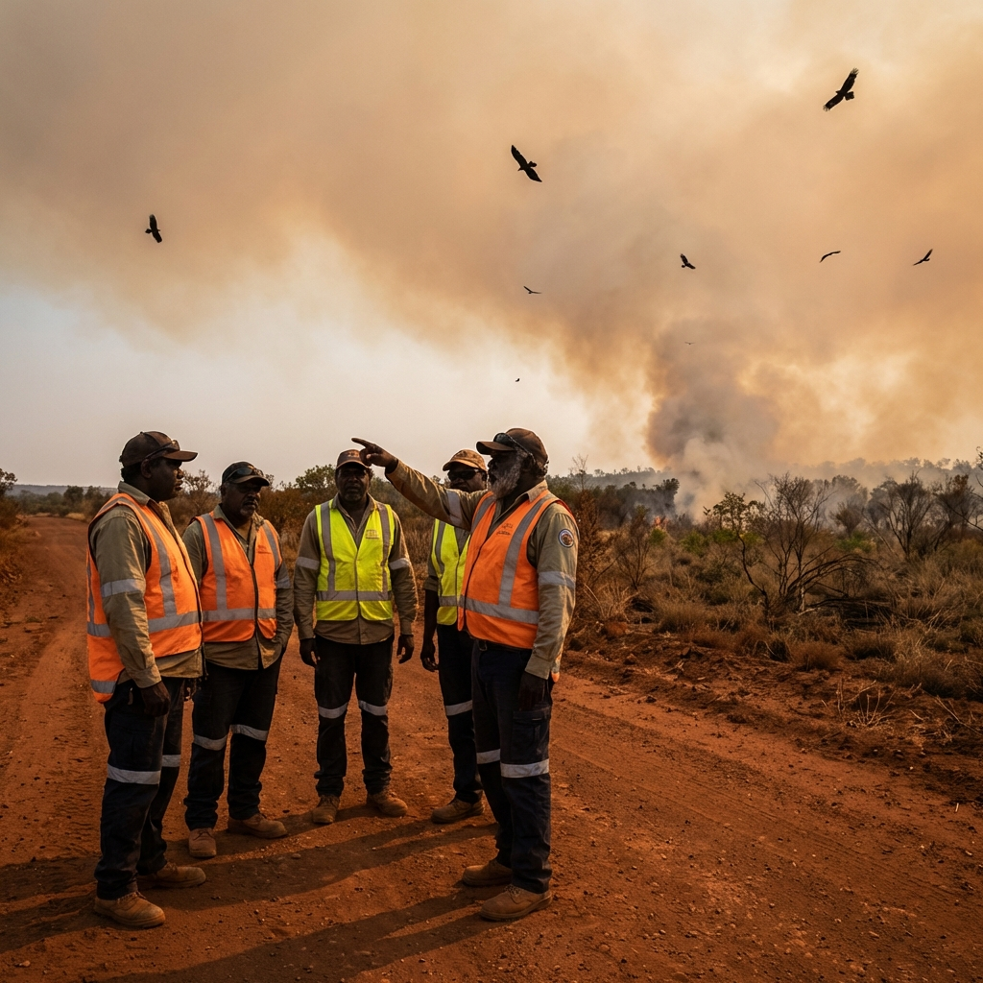

# 05. THE BIG QUESTION

Is it Intentional or Accidental? This is the heart of the scientific debate.

|  |  |
| --- | --- |
| **WHY IT'S REAL (Intentional):** | **THE SKEPTICS SAY (Accidental):** |
| * Reports are consistent and describe 'goal-directed' actions. * Only a small percentage of birds do it, suggesting learning. * Birds sometimes work together to move fire across barriers. | * We still don't have clear video of a bird starting a fire on purpose. * It's hard to tell if they grabbed a stick by accident while hunting. * We don't see this happening in other countries. |

# 06. LIVING WITH FIREHAWKS

In the Northern Territory, fire managers already plan for these birds when conducting controlled burns. A Firehawk can easily carry a blaze across a firebreak, making their job much more difficult.

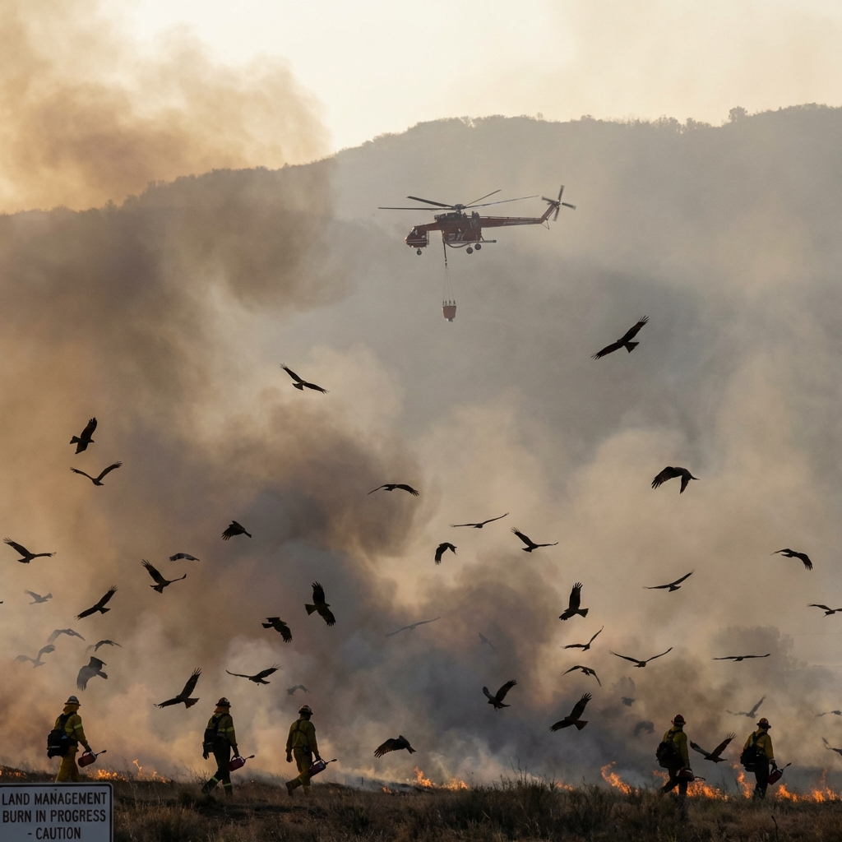

# 07. THE SEARCH CONTINUES

As of 2026, the case remains 'well-supported but not conclusively proven' by Western science. The connection between ancient Indigenous stories and modern observations has changed how we think about animal intelligence.

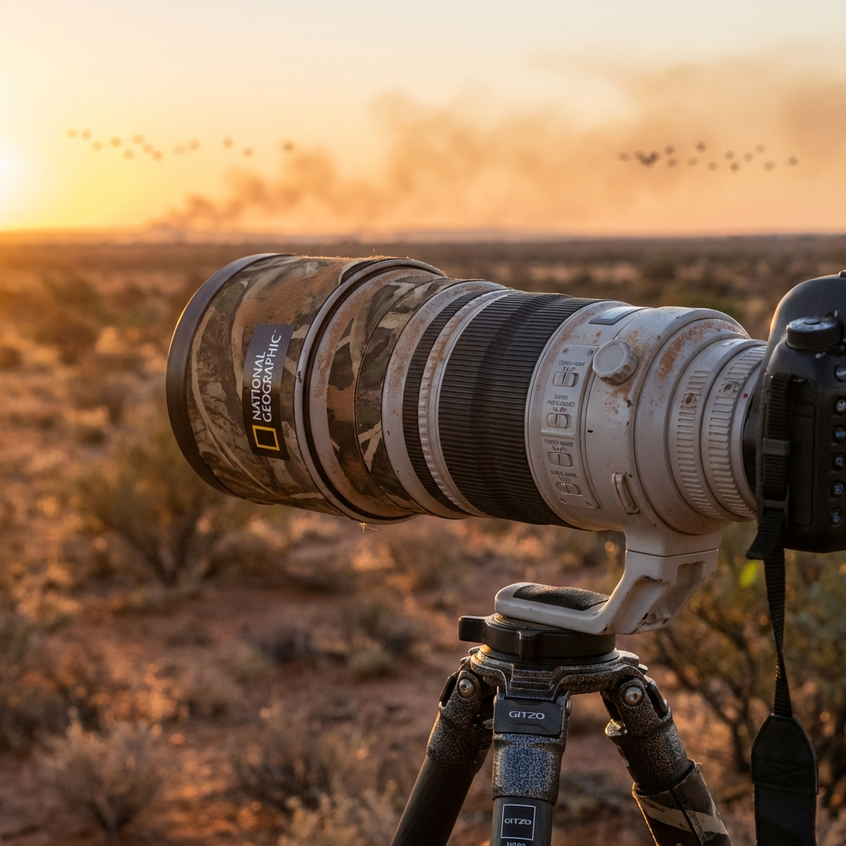

# 08. CONCLUSION

The Firehawk teaches us that nature is full of surprises. It is a reminder to look closely at the bush—there might be a master hunter at work in the smoke!

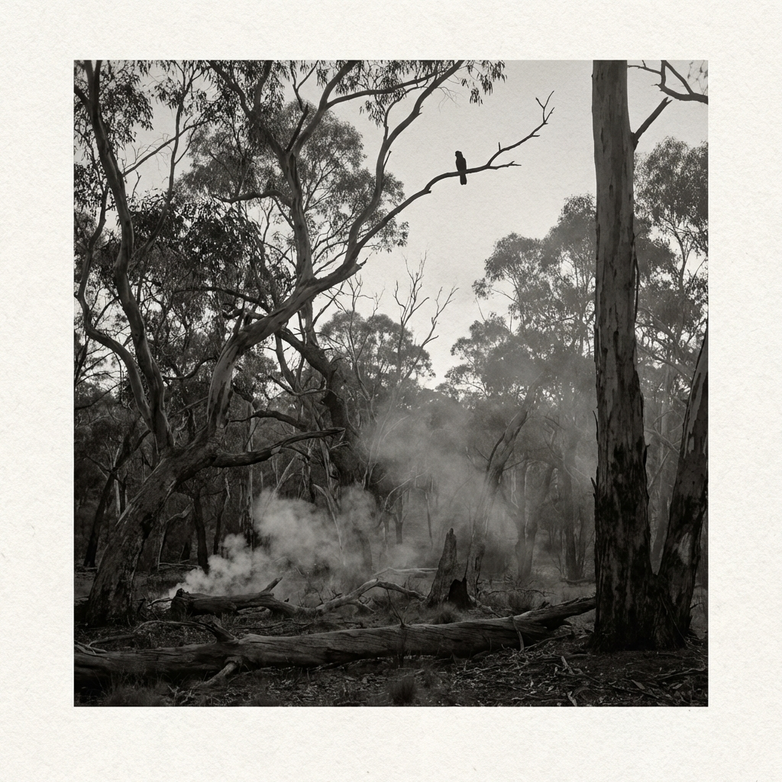

# COMPREHENSION CHECK

1. Identify the three species of birds described as 'Firehawks' and one characteristic of each.
2. Describe the five steps of the 'Behavioural Mechanism' used by these birds to spread fire.
3. Why is the behaviour of the Firehawks still considered a controversy in Western science?
4. How do fire managers in the Northern Territory adapt their strategies to account for Firehawks?
5. What does the author mean by saying the Firehawk is a 'bridge between two worlds of knowledge'?